**Further technical documentation NavCampus**

IDEF0



Use Case:

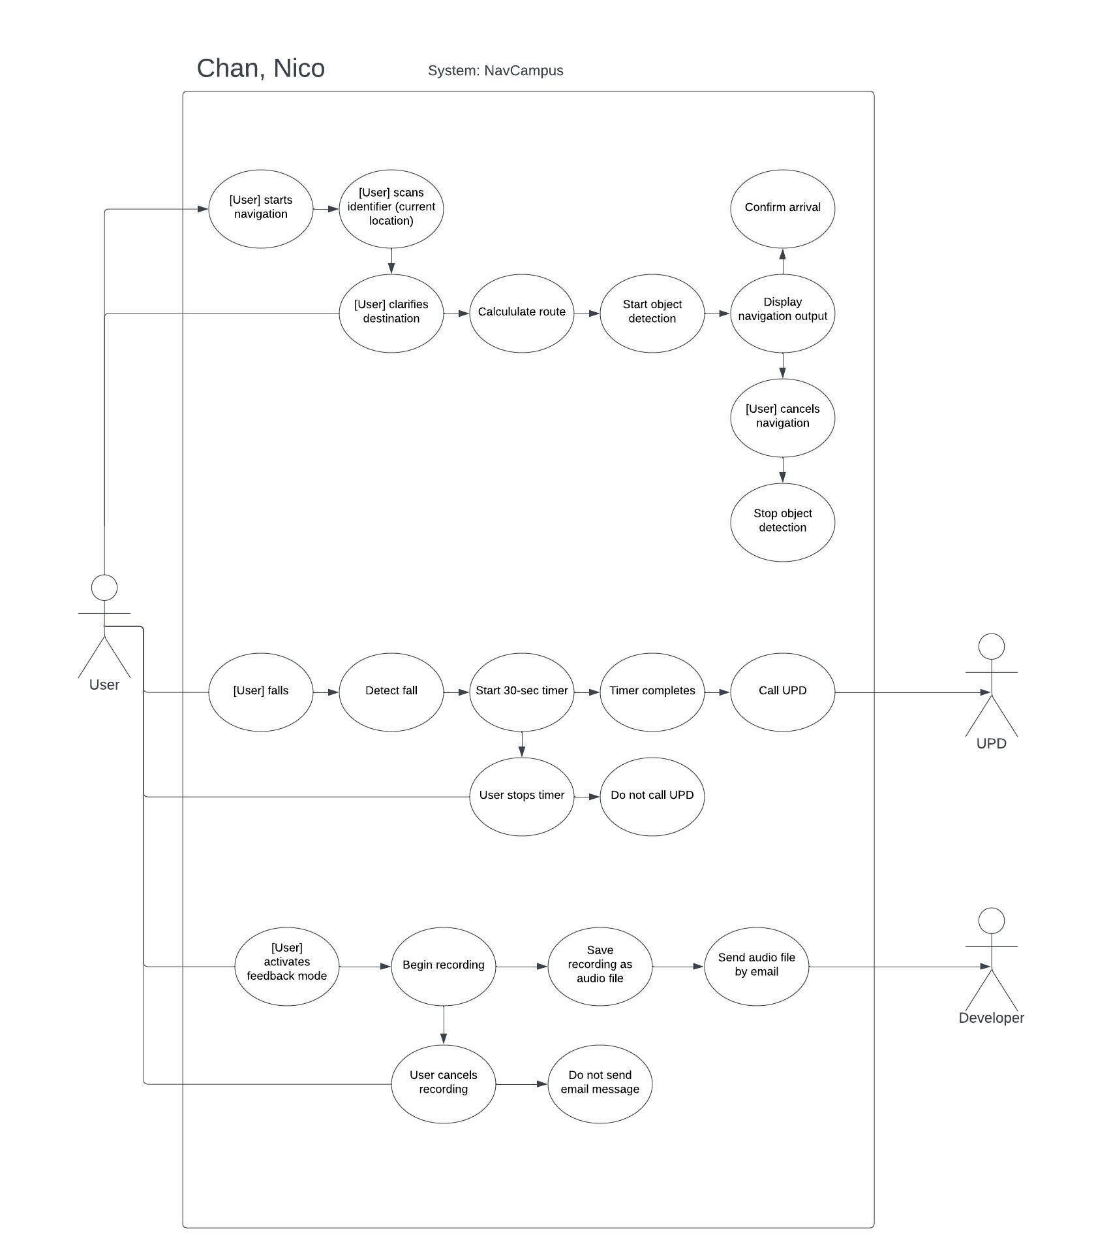

Sequence diagram:





Class diagram:

